

**NAMES**

TINASHE DALE CHADZINGWA R205016F(HACS)

ASHELL SENGU R205030J(HACS)

**TIME SERIES ANALYSIS FOR SOUTH AFRICA GDP**

**Table of contents**

**CHAPTER 1: Introduction**

* 1. Abstract
  2. Introduction
  3. Problem Statement
  4. Significance of study
  5. Objectives

**CHAPTER 2: Literature Review**

2.1 What is time series

2.2 Review of elementary time series and models

2.3 Methods of trend and isolation

2.4 Analysis of GDP using time series

**CHAPTER 3: Methodology**

3.1 Research methodeology

3.2 Data source and nature

3.3 Data capturing and analysis

3.4 Data analysis

3.5 Conclusion

**CHAPTER 4: Results and Analysis**

4.0 Data Display

4.1 Results and data analysis

4.2 Model diagnostics

4.3 Model fitting

4.4 Forecasting

4.5 Conclusion

**Appendix**

References

**TOPIC- TIME SERIES ANALYSIS FOR GDP GROWTH IN SOUTH AFRICA**

1.0 ABSTRACT

Gross Domestic Product is one of the most essential economic indicators of a country and its positive or negative growth indicates the economic development of the country. It is calculated quarterly and yearly at the end of the financial period. To keep on track on the GDP growth is one of the parameters for deciding the economic policies of the country. In this study, we are analyzing and forecasting the GDP growth using the time series forecasting techniques using R software. This model can assist policymakers in framing policies or making decisions. Furthermore, the constructed model will facilitate the prediction of standards of living in South Africa during the period under study and future timeline.

1.1 INTRODUCTION

The Gross Domestic Product (GDP) is the value in totality of the services and goods produced within the geographic limits of a nation. It is measured over a specific period of time intervals within a year that is quarterly or once a year. It is one of the most powerful statistical economic indicators that are used to assess the economic performance and development of the country. It is also used to compare the economic health of the country at two points of time. The concept of GDP was first brought about by William petty in UK between 1654 and 1676 to address the issue of unfair taxation by landlords during the warfare between the English and Dutch. However, the modern concept of GDP was given by Simon Kuznets for US Congress report in 1934. GDP which can be viewed as national income(Y) is comprised of four components namely domestic consumption(C), government expenditure(G), investment(I) and net exports(X-M). Therefore;

Y=C+G+I+(X-M).

GDP is measured by three methods

● Income based method

● Output based method

● Expenditure method

GDP growth rate indicates the rate at which economy of country is growing positively or negatively. It is an important indicator used to measure development of a country with respect to time. Positive GDP growth rate of country indicates its economy is flourishing while a negative GDP growth indicates possible economic downturn. It acts as an aiding tool to economists in strategy formulation and policy framing of the country’s economy related policies. It also helps investors in making investment related decisions. GDP directly affects business, stock market, jobs and personal income and lower GDP indicates low stock prices and low standards of living.

GDP Growth Rate= [(GDP1)/ (GDP2)-1]

Where GDP1 is GDP for year1 and GDP2 is GDP for year2.

1.3 PROBLEM STATEMENT

GDP being a crucial measure of economic performance of a country, its sustained and accurate understanding is of utmost importance. Thus, monitored behavior of GDP over time ensures the minimization of ineffective economic policy and downward fall of living standards.

1.4 SIGNIFICANCE OF STUDY

The importance of this research is to analyze the economic performance of south Africa I the period 1946 to 2007. This facilitates a clear comprehension of the effectiveness of policies used in the timeline and the general living standard of a basic south African household. It further allows determination of the GDP growth trend which provides a forecast for the expected performance of the nation’s economy thus helping effective planning in businesses, stock market, government spending and investment.

1.5 OBJECTIVES

* Analysing GDP growth (economic performance) of South Africa from 1946 to 2007
* Forecasting inflation rate of south Africa
* Forecasting the living standards of south African citizens
* Forecasting the GDP growth trend in south Africa from 2007 to 2015

**CHAPTER 2**

2.0 **LITERATURE REVIEW**

**2.1 What is time series?**

A time series is a series of observations or data points recorded sequentially over time at equally spaced  
intervals (Cyber, JD, 2005)

**2.2 Time Series Plot**

Before we can venture to understand and analyse a time series we need to appreciate its nature and appearance over time. There may be patterns in the time series that we can visually see and thus, we are guided in  
our analysis. These patterns are also acknowledge the components of the time series which includes the trend, cyclical Variation ©,Seasonal Variation (S)  
Irregular or Random Variation(I)

A time series plot gives us a visual impression of the time series. This is usually a plot of the response or variable of interest (Z) against time (t), denoted Zt,

**2.3 Review of Elementary Time Series and models**

**Components of a Time Series**

Time series analysis assumes that our underlying forces, individually or collectively determines the  
random variable's value in a time series in any time period. They are:  
 * Trend (T)

* Cyclical Variation (C)

*Seasonal Variation (S)

*Irregular or Random Variation (or (R).

Trend (T)

This is the general increase or decrease in the time series over an extended period of time caused by long-term trends, for example, population growth.  
In other words, it is the long-term smooth underlying movement in a time series. It describes the effect  
that long-term factors have on the series.

**Cyclical Variation ©**

The cyclical component of a time series describes alternating periods of relative expansion and contraction of more than one year duration. These periods are known as cycles. Cyclical variations occur because of upward and downward swings in the general cycle of prosperity,  
recession, depression and recovery. This wavelike patterns, with the periods of expansion and contraction not of equal length, describes a long term trend that is generally apparent over a number of years.  
  
**Seasonal Variation (S)**  
  
Seasonal variation occurs over short repetitive calendar periods and have a duration of less than a year and represent predictive deviation from the trend, for example, annual agricultural crop yield.

**Irregular (Random) Variation (I)**

Random variations occur over short intervals and are unpredictable, with no patterns to their behavior,They tend to link the existence of the other more predictable components. Examples of what causes these movements are unexpected changes in the weather, political unrest, theft and war,

Decomposition of a Time Series

The main aim of time series analysis is to Isolate the influence of each of the four components on the actual time series.

Multiplication Model  
Z =T x C x S x I

Where  
Z-Actual value of a time series

T=Trend component Measured in the actual units

C=cyclical index expressed relative to the trend

S=Seasonal Index expressed relative to C and T

I= irregular component

We can use statistical analysis to isolate the trend and the seasonal components

Additive Model  
Z=T+C+S+I

2.4 Trend Analysis

We can identify the trend in a time series by averaging out the short term fluctuations in the series this will result in either a smooth curve or a straight line.

2.5 Methods of Trend Isolation

* The moving average method which produces a smooth curve

* Regression analysis which involves fitting a straight line

Methods of Moving Average  
The moving average method Smoothies out peaks and valleys in a set of observations. The objective is to bring out the trend by eliminating any obscuring seasonal cyclical or random fluctuations. One of its  
drawbacks is that value for some years are lost at the beginning and end of the series.

Autoregressive Process of Order p. AR (p)  
  
Autoregressive processes are regressions on themselves,  
Definition: A process {Zt} is called an autoregressive process of order p.  
AR (p), if it can be expressed in the form

**Zt= ϕZt-1 +….+ϕZt-p +at**

Where {at} ls a white noise process such that at independent of **Zt,,Zt-2**….

A current value of the series is a linear combination of the most recent past vales  
of itself plus an innovation term, a, which incorporates everything in the series at  
time, that is not explained by the past values as assumed to be independent of  
Zt,,Zt-2…..

Stationarity of an Autoregressive Process

AN AR(p) **Zt= ϕZt-1 +….+ϕZt-p +at,** can be expressed as follows in  
terms of the backward shift operator

**Zt - ϕZt-1 -….-ϕZt-p =at**

**ϕ(B)Zt =at**

In order to check whether an AR {p) is stationary or not, we use the characteristic Equation of the roots of **ϕ(B)** = 0 in absolute values are greater than unit, then the process (Zt) is stationary

The Mixed Autoregressive Moving Average Process  
A general mixed autoregressive-moving average process is a process that we get by  
Combining both MA (q) and AR (p) processes. We denote this process ARMA (p, q) and is given by

**Zt = ϕZt-1 -….-ϕZt-p =at-θqat-q**

2.6 Model Building strategy

We find an appropriate model using a technique developed by Box and Jenkins in 1976. The Box-Jenkins methodology consist of a four step iterative procedure

Step 1. Tentative Identification

Step 2 Estimation

Step 3 Diagnostic Checking

Step 4 Forecasting

These four steps shall be looked at in detail as we proceed with our project.

2.7 ANALYSIS OF GDP using Time Series

Since a non stationary time series must be made stationary , some statistical tests are followed so that the time series becomes stationary and intergrated to the order I. (Hassan 2021). Box-Jenkins proceedure is used to determine ARMA. OLS is used to estimate the models parameters. Performances chosen ARIMA model are verifies on the basis of classical statistical tests and forecasting. The model features are interpretted on basis of Standard measures of forecasting performance

**CHAPTER 3**

3.0 **Methodology**

Data was collected and relevant data items are to be highlighted and extracted from a master data set of world Population. Excel pivot tables were used in the screening of this data

The methodology adopted and the following steps and the description of the steps involved in

the sequence. At the end, the evaluation is performed and the final results are obtained.

a. Data collection. We have collected the GDP growth data for India from 1947-2007 from a comma-

separated (CSV) file available for download on the official website of Open

Platform India, and uploaded that in Excel 2013.Then data was cleaned , extracted and converted into Time

series data to be used for analysis and forecasting in R studio software.

b. Analysis of data. Data was analyzed for missing values and plotted to visualize the GDP growth of South Africa from

1947-2007

c. Time series forecasting. Time series forecasting with ARIMA Model and PROPHET is used for forecasting

the trend of GDP growth in the near future, i.e. for next ten years from 2010-2030.

d. Validation of results. Models are validated on the basis of comparison of actual test data with the forecasted

data by dividing the dataset into a training set and testing set. The model prediction is then tested on test data

for ten years with actual data to check the predictive capability of the mode

3.1 Data source and nature

Yearly GDP were obtained for the period of 1947 to 2007. The data is used for time

series of the GDP of South African economy ). The data has been

obtained from the following website www.worldeco.com

3.2 Data capturing and analysis

Data capturing and analysis was done using two main Statistical Packages that is

• Excel

• R

These Statistical Packages were used to

• Times series plots

* Determine other time series data

• Graphs

• Forecast

Data analysis

During data analysis, R was used to

• ta determine the pattern and trends in the Annual GDP of South Africa

• To check the model adequacy relevant graphs are produced

Once the adequate model is suggested, it is fitted using the unknown parameters calculated

3.4. Conclusion

The fitted model will be used for future forecasting using R by simply specifying the parameters

of the model and the length of the period to be forecasted. In modelling the function a Box Jenkins

procedure is to be followed for a fully modified model.

**CHAPTER 4**

**4.0 DATA DISPLAY**

**RESULTANT TIME SERIES**

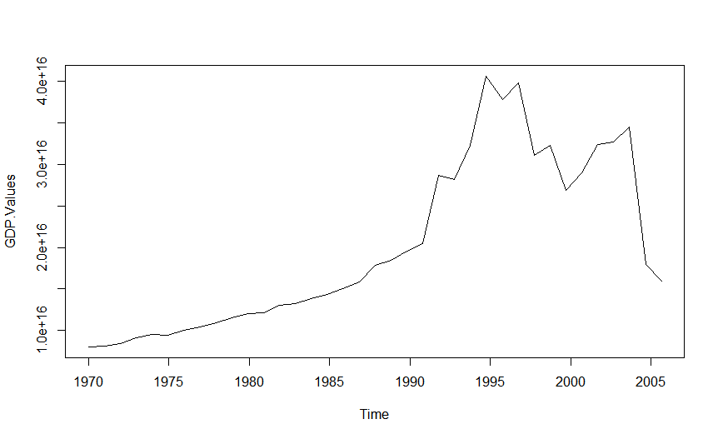

The given data produced the above time series plot .

**TREND**

The GDP of South Africa in the specific period of 1946 to 2007 resulted in a positive trend indicating economic growth.

**4.1 RESULTS AND DATA ANALYSIS**

**Autocorrelation function analysis**

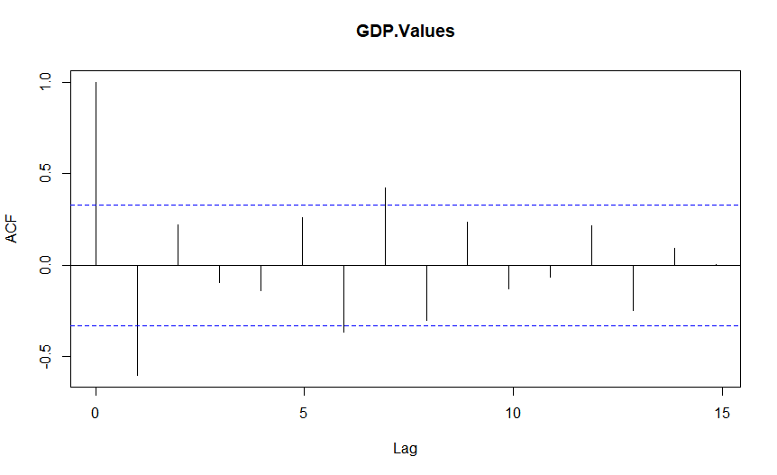

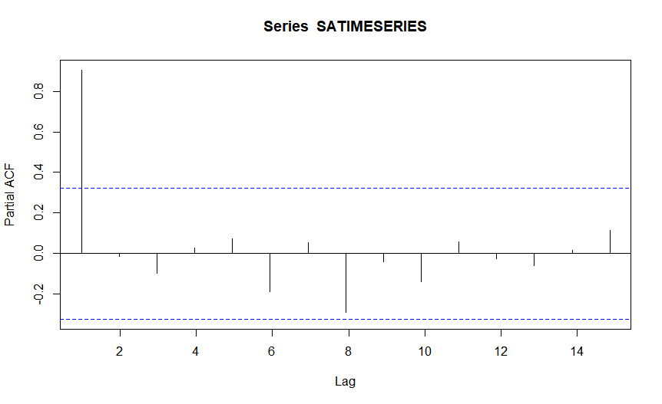

ACF AND PACF AFTER DIFFERENCING

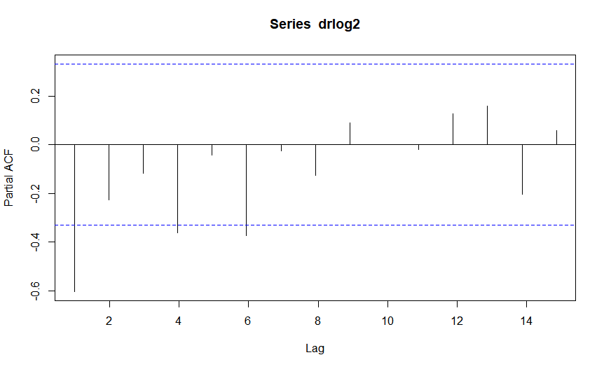



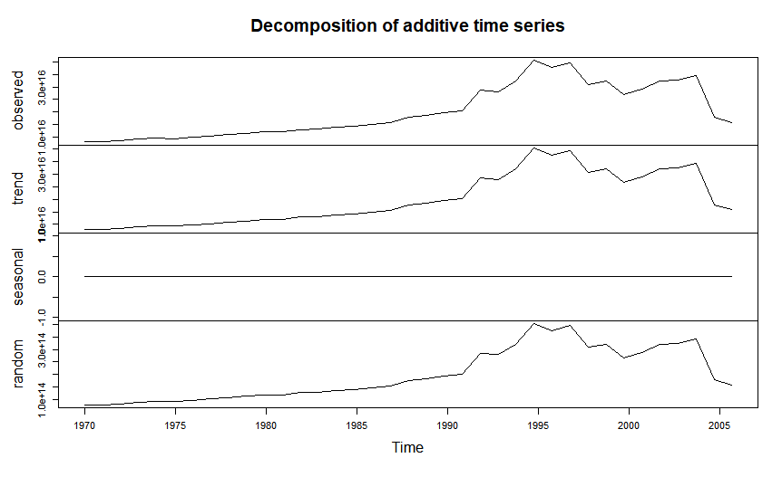

The decomposition of our model, additive model shows that there was no seasonality component in our time series hence there was no need to factor out seasonality from our Given GDP data

**Differenced time series using log differencing twice**

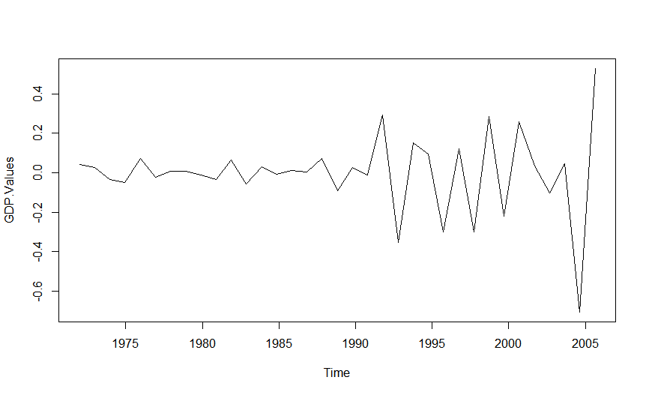

**4.3 MODEL DIAGNOSTICS**

**Validating model adequacy**

Checking the normality assumption

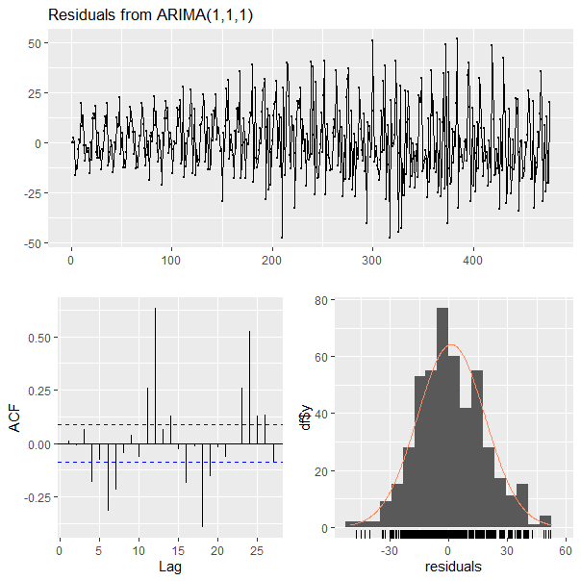

The error terms are normally distributed because the graph is bell shaped

**Checking for Independence**

Scatter Plot

**4.4 MODEL FITTING**

Final estimates of parameters

|  |  |  |
| --- | --- | --- |
| TYPE | Coefficient | SE Coefficient |
| AR 1 | -0.1855 | 0.2420 |
| MA 1 | -0.7615 | 0.2206 |

This model was differenced twice to achieve Stationarity

We assume that the P Values for the coefficients of MA (1) and AR(1) are significant

The fitted model ARIMA(1,2,1) is valid

**Zt = at + ϕ1Zt-1 -θ1at-1.**

**Zt = at -0.1855Zt-1 +0.7615at-1.**

**4.7 FORECASTING**

Below are the forecasts of the GDP For the next 6 Years from December 2007

|  |  |
| --- | --- |
| PERIOD | FORECAST |
| 2008 | 15014102291212724 |
| 2009 | 9.13213E+15 |
| 2010 | 5.2601E+15 |
| 2011 | 3.02982E+15 |
| 2012 | 1.74518E+15 |
| 2013 | 1.00522E+15 |

**CONCLUSION**

In a nutshell, the research was focused on analyzing the economic performance of South Africa by evaluating the behaviour of its GDP over a time period from 1946 to 2007. We used the forecasting techniques of timesries that R and ARIMA model to forecast GDP growth for 2008 to 2013. The ARIMA(1,2,1) fits the model and has indicated good predictive capabilities for the GDP for South Africa

APPENDIX

**REFERENCES**

Cyber J D (2005) A Study of a New Method for an Old Behavior Paper published at the Journal of Educational Computing Research, 2005, 32(3), 265-277

Hassan MALIK MABASHER (2021) Using time series forecasting for analysis of GDP Growth in India. International Journal of Education and Management Engineering. 11(3) :40-49.

J. Education and Management Engineering, 2021, 3, 40-49 Published Online June 2021 in MECS (http://www.mecs-press.org/) DOI: 10.5815/ijeme.2021.03.0

Decent standard of living index final report, October 2018,

OECD (2009), National Accounts of OECD Countries 2009, Volume I, Main Aggregates, OECD Publishing, http://dx.doi.org/10.1787/na_vol_1-2009-en-fr.